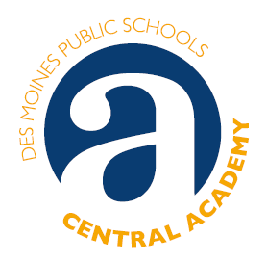
Prep Academy News
Wednesday, August 30, 2023
***********************************************************************************************************
WELCOME TO PREP ACADEMY 2023-2024!
We are glad you are here.

The Upstairs Team! The Downstairs Team!
Ms. Luci Core Mr. Jeffrey Marks Mr. Desman Oakley Ms. Lana Lyddon Hatten
English-Room 2014 Math–Room 2016 English-Room 1013 Math-Room 1020
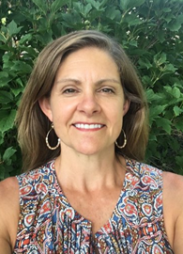
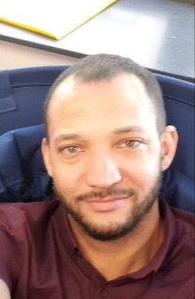
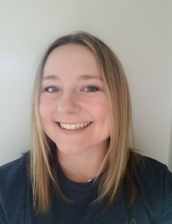

Prep Academy Support Staff
Diane Fox Jenny Schiltz Kelly Randleman
Prep Academy Prep Academy Advisor Central Academy
Interim Advisor (beginning Nov. 2023) Advanced Learning Consultant
Room 1017 Room 1017 Room 3020
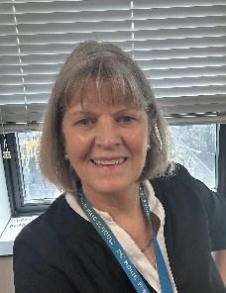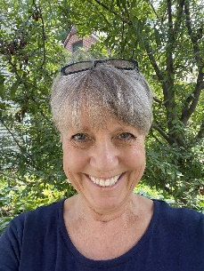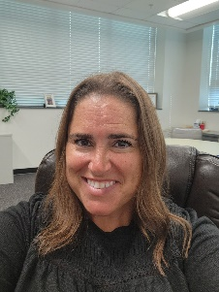

TO CONTACT US
If you have questions or concerns about participation in the Prep Academy. We’re here to help!
Diane Fox -- Prep Academy Advisor diane.fox@dmschools.org or call (515)242-7357
Kelly Randleman -- Central Academy Advanced Learning consultant Kelly.randleman@dmschools.org
Lana Lyddon Hatten – Math lana.lyddonhatten@dmschools.org
Desman Oakley – English desman.oakley@dmschools.org
Jeff Marks – Math jeffrey.marks@dmschools.org
Luci Core – English lucinda.core@dmschools.org

IF YOU ARE ABSENT
In addition to contacting your student’s home school, please contact the Central Academy Attendance Clerk at 242-7653 or email Jamie.trogdon@dmschools.org

