We are so excited that you are joining us at Central Academy this year! As a student entering eighth grade Honors English, you should take some time this summer to read to prepare for your English class. Please read one of the following books:
Read the book once for enjoyment. Pay attention and mark key passages or moments in the text that engage you. Think about the role that each character plays in the story. What is the author’s message? Finally, decide on FOUR quotations that you think help show either some aspect about a character or some support for the message of the book. Happy Reading!
Please bring your book (with marked passages) and your four quotations on the first day of class.
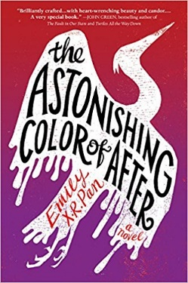
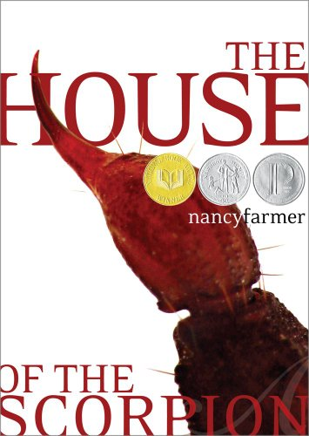

Orson Scott Card  Ender's Game  The Earth is under attack by aliens and the government is developing a group of military geniuses and training them with military games. Ender Wiggins is one of the trainees. | Nancy Farmer  The House of the Scorpion  A scientist brings Matteo to life from a frozen 100 year old cell. Matteo is a clone of a powerful drug lord. The novel traces his struggles to stay alive and his increasing awareness of the country named Opium. | Emily X.R. Pan  The Astonishing Color of After  Leigh Chen Sanders is absolutely certain about one thing: When her mother died by suicide, she turned into a bird.
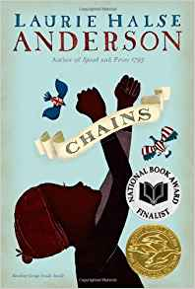 | 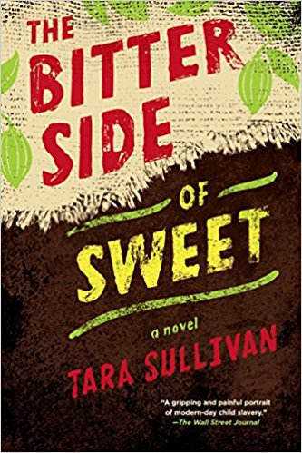

Laurie Anderson  Chains  As the Revolutionary War begins, thirteen-year-old Isabel wages her own fight...for freedom. Promised freedom upon the death of their owner, she and her sister, Ruth, in a cruel twist of fate become the property of a malicious New York City couple. | Tara Sullivan  The Bitter Side of Sweet  Two boys only wanted to make money to help their impoverished family, instead they were tricked into forced labor on a plantation in the Ivory Coast—until Khadija comes into their lives. | Angie Thompson  The Hate You Give  Sixteen-year-old Starr Carter moves between two worlds: the poor neighborhood where she lives and the fancy suburban prep school she attends.
We know you have read many novels throughout your lives. At Central Academy, though, we need you to start reading analytically and with purpose. To that end, when you choose your summer reading book, we want you to focus on a characterization as it relates to a motif and a theme as you read the novel.
Characterization is a method used by authors to describe a character. More than that, though, authors use this technique to tell us something about the work beyond just the character. There are five methods of characterization: physical description, action, inner thoughts, reactions, and speech. We look to these methods of characterization in order to formulate a meaning about that character and about the larger meaning of the work.
A motif is a recurrent thematic element in a literary work. It is usually one word or a short phrase and helps to lead to a lesson a work is teaching. For example, common motifs through literature are family, childhood, redemption and the like.
There are many motifs that run through the summer reading choices. As you read your novel, we want you to choose one character on which to focus, paying attention to how that character helps illuminate (show more about) a motif. There are several motifs below from which to choose.
Friendship
Family
Courage
Non-conformity
Alienation
Control
Power
Manipulation
War
Abuse
Identity
Social status

Try to choose a motif to which you can relate in your own life. That will help you in making connections. As you read, you need to find at least five quotations (write them down with the page number) that would show how the characterization of the character you chose supports your motif. Try to keep in mind how that motif can help you find a theme.
A theme is a universal human truth. Universal means it should not be specific to the book but to life and the human condition. A theme cannot be just one word and does not tell people what to do. Finally, the theme must keep the whole work in mind, especially the end.
In the end, we want you to look at the quotations you have chosen and your ideas about your character and motif and try to determine a theme. This work will be the basis of the paper you will write when you come back to school in August.
Here is an example:
The example is going to be from a movie so as not to use the books you are reading. The Princess Bride is an amazing movie and could use many of these same motifs. Let’s use the motif of friendship.
If I were reading this book (and there is an awesome book by William Golding from which this movie was created), I would be paying attention to when the idea of friendship was mentioned. I would be marking the quotations and the page numbers. It starts out with the friendship between Buttercup and Westley which eventually turns into love. There is also the friendship between Fezzik and Inigo which lasts through the work. As I am noticing all of this, I also need to be thinking about one character I want to focus on and what methods of characterization are used. Additionally, what lesson the author might be trying to teach about the idea of friendship through that character. After I have finished the book and written my five quotations, I will look through them and try to determine what lessons were taught.
Here are two examples of themes I might use:
- Friendship can last through any turmoil as long as each person always has faith in the other.
- If people have true friends, then they can make it through any difficult situation.
Let’s go back up and make sure these themes have followed the directions from the definition.
A theme is a universal human truth. Universal means it should not be specific to the book but to life and the human condition. A theme cannot be just one word and does not tell people what to do. Finally, the theme must keep the whole work in mind, especially the end.
These ARE universal. Notice how neither of these themes references any of the specific characters from the work. Instead, they attempt to show what Golding might have been teaching about the idea of friendship by using this story.
These are NOT one word and they do not tell people what to do.
Finally, these do keep the end of the work in mind. If they all died at the end, these would not work because friendship did not get them through any difficult situation.
Weak themes:
Telling people what to do-- People should always support their friends through thick and thin.
We are not attempting to dictate how people behave or suggest that the author intended that, but instead, we are gleaning a lesson from the story that we might choose to live by as we age.
One word—The theme is friendship.
This gives no lesson and is simply a motif.
Not universal—Buttercup learns that if she just had faith in Westley, everything would have been okay.
Though we are using the book to decide upon the lesson, the theme moves away from the book to show what is true for everyone and not just Buttercup.
Now, it is your turn—
- Select your book
- Select your motif
- Read the book underlining quotations that relate to that character and motif
- When you are done reading,
  - Explain which character you are using and describe all the five elements of characterization for him or her.
  - Then, look at the quotations and the ideas you learned and create a theme following the rules above.
- Finally, write down your theme and your five quotations that would best support that theme.
- When you come in August, bring these with so we can hit the ground running.

Oh, one last note. You should write your quotations following MLA guidelines. All citations will have quotation marks and no end punctuation (or comma at the end of the citation before the quotation marks) inside the quotation marks unless it is a question mark or exclamation mark. Otherwise, the period goes outside of the parenthetical citation only. See examples below.
“Anybody want a peanut?” (65). “Don’t go against a Sicilian when death is on the line!” (123).
“As you wish” (5).
1. | Book Title | Book author
2. | Motif choice | Explanation of why you chose that motif
3. | Character choice | Explanation of why you chose that character
4 | Theme | Explanation of theme
5 | Quotation 1 with MLA citation | Explanation of how quote ties to theme
 | Quotation 2 with MLA citation | Explanation of how quote ties to theme
 | Quotation 3 with MLA citation | Explanation of how quote ties to theme
 | Quotation 4 with MLA citation | Explanation of how quote ties to theme
 | Quotation 5 with MLA citation | Explanation of how quote ties to theme

