World History: People and Places
Summer Assignment
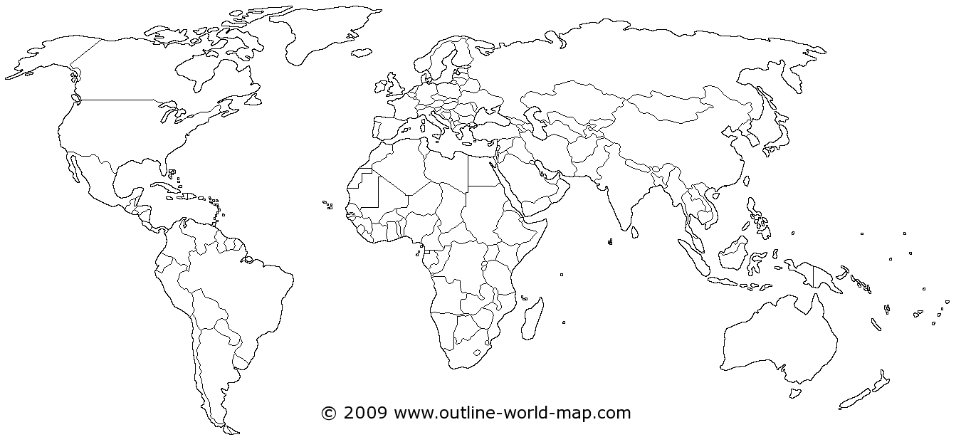
Locate and color-code each of the following countries on the map above: 1) Bangladesh, 2) Belgium, 3) Brazil, 4) China, 5) Cuba, 6) Egypt, 7) France, 8) India, 9) Iran, 10) Israel, 11) Japan, 12) Korea, 13) Mexico, 14) Nigeria, 15) Pakistan, 16) Russian Federation, 17) Saudi Arabia, 18) Serbia, 19) United States of America, 20) Vietnam
Research and record the following information for each country: A) most spoken language, B) 2nd most spoken language, C) official language, D) dominant religion(s), E) structure of national government, F) any relevant physical features.

