We are so excited that you are joining us at Central Academy this year! As a student entering eighth grade Honors English, you should take some time this summer to read to prepare for your English class. Please read one of the following books:
Read the book once for enjoyment. Pay attention and mark key passages or moments in the text that engage you. Think about the role that each character plays in the story. What is the author’s message? Finally, decide on FOUR quotations that you think help show either some aspect about a character or some support for the message of the book. Happy Reading!
Please bring your book (with marked passages) and your four quotations on the first day of class.

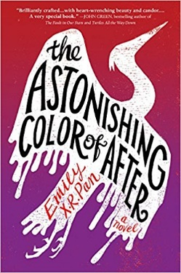
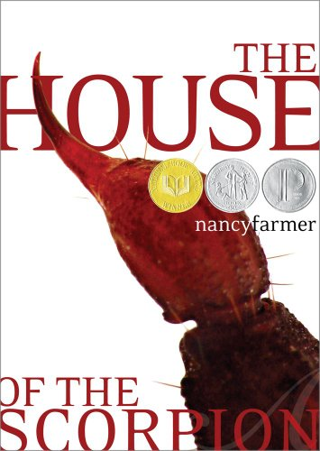

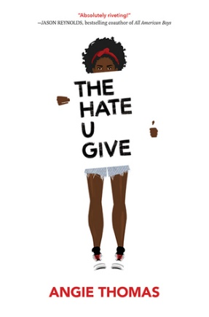
Orson Scott Card  Ender's Game  The Earth is under attack by aliens and the government is developing a group of military geniuses and training them with military games. Ender Wiggins is one of the trainees. | Nancy Farmer  The House of the Scorpion  A scientist brings Matteo to life from a frozen 100 year old cell. Matteo is a clone of a powerful drug lord. The novel traces his struggles to stay alive and his increasing awareness of the country named Opium. | Emily X.R. Pan  The Astonishing Color of After  Leigh Chen Sanders is absolutely certain about one thing: When her mother died by suicide, she turned into a bird.
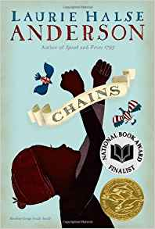 | 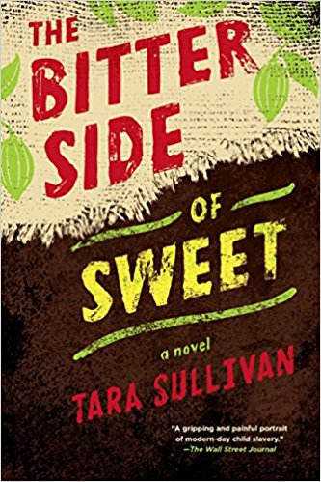

Laurie Anderson  Chains  As the Revolutionary War begins, thirteen-year-old Isabel wages her own fight...for freedom. Promised freedom upon the death of their owner, she and her sister, Ruth, in a cruel twist of fate become the property of a malicious New York City couple. | Tara Sullivan  The Bitter Side of Sweet  Two boys only wanted to make money to help their impoverished family, instead they were tricked into forced labor on a plantation in the Ivory Coast—until Khadija comes into their lives. | Angie Thompson  The Hate You Give  Sixteen-year-old Starr Carter moves between two worlds: the poor neighborhood where she lives and the fancy suburban prep school she attends.

