Book Assignment

This year will begin with an assignment using the selection of books listed below.
These books are nonfiction accounts of people doing great things for others. The books, which are available in paperback, can be found at local libraries and bookshops. Choose at least one to read. As you read, annotate the text and/or write notes, paying particular attention to passages that illustrate the power of the individual to effect change. All of the individuals are working against an oppressive system; if you are not familiar with the oppressive system, spend time learning more about it. Bring the book and all notes with you to your first Advanced Placement English Language and Composition class. Read the following press releases for more information.

Just Mercy
by Bryan Stevenson
Just Mercy is at once an unforgettable account of an idealistic, gifted young lawyer’s coming of age, a moving window into the lives of those he has defended, and an inspiring argument for compassion in the pursuit of justice. Through his own experiences and his work with juvenile offenders and the wrongly accused, we have a first-hand look at the broken criminal justice system.
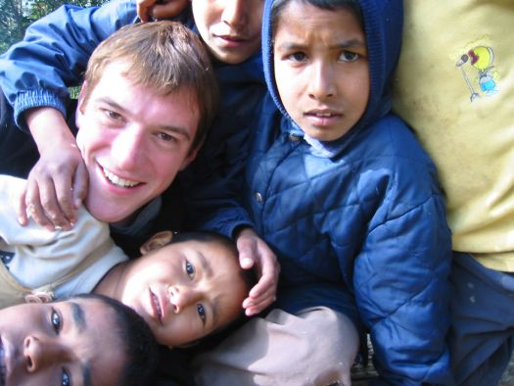
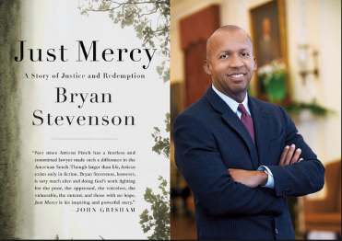
Little Princes: One Man’s Promise to Bring Home the Lost Children of Nepal
by Conor Grennan
Little Princes is the epic story of Conor Grennan's battle to save the lost children of Nepal and how he found himself in the process. Part Three Cups of Tea, part Into Thin Air, Grennan's remarkable memoir is at once gripping and inspirational, and it carries us deep into an exotic world that most readers know little about.

Mountains Beyond Mountains
by Tracy Kidder
Paul Farmer found his life’s calling: to cure infectious diseases and to bring the lifesaving tools of modern medicine to those who need them most. Kidder’s magnificent account takes us from Harvard to Haiti, Peru, Cuba, and Russia as Farmer changes minds and practices through his dedication to the philosophy that “the only real nation is humanity.”

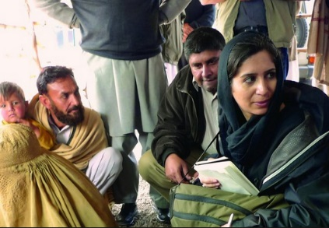
I Was Told To Come Alone: My Time Behind the Lines of Jihad
By Souad Mekhennet
In this compelling and evocative memoir, we accompany Mekhennet as she journeys behind the lines of jihad, starting in the German neighborhoods where the 9/11 plotters were radicalized and the Iraqi neighborhoods where Sunnis and Shia turned against one another, and culminating on the Turkish/Syrian border region where ISIS is a daily presence. In her travels across the Middle East and North Africa, she documents her chilling run-ins with various intelligence services and shows why the Arab Spring never lived up to its promise. She then returns to Europe, first in London, where she uncovers the identity of the notorious ISIS executioner “Jihadi John,” and then in France, Belgium, and her native Germany, where terror has come to the heart of western civilization.stern Civilization.

To prepare for the first day of class, rhetorically analyze the books by completing the steps below. You will turn in your notes with your first writing assignment. As you prepare your notes, label the different segments. These can be handwritten or typed but should be neat and easy to read.

Any memoir/autobiography/biography will have a purpose, and it will focus on a series of events throughout a person’s life, selecting certain moments, leaving out others. Through a narrative, which will often include description, dialogue, and reflection, the writer seeks to explain a greater idea and often multiple ideas. As you read your book, think about the role of the writer. See it through the lens of the author him/herself. (Note: An autobiography focuses on the chronology of the writer’s entire life while a memoir covers one specific aspect of the writer’s life. A biography is the story of events and circumstances of a person’s life, written by someone other than that person.)
Step 1: In a single sentence, identify the author, the title, the type of book (autobiography/memoir/biography) the publication date, and the purpose. Beneath that sentence, include the properly formatted MLA citation for the book.

Step 2: Divide the book into four to five sections based on rhetorical purpose. Label each section and include two quotations for each section which provide insight into the subject’s journey. After choosing the quotations, introduce them with a sentence or two to explain what these quotations reveal about the subject or the situation. You might consider early upbringing and access to/denial of basic rights, or the political climate in the area. Be sure to make claims. A label like “childhood” does little to explain the author’s choices.

Step 3: In one to two paragraphs, examine how the author organizes the text. Does each chapter end with a “cliffhanger” designed to move the reader to the next chapter? How does the writer begin a new chapter? Does the author number the chapters or do they use titles? Does the writer use a central story and then branch off from there but come back to that story? Does the author include images—if so, what are they and where do they appear?

Step 4: Finally, choose and analyze two to three quotations which encapsulate the writer’s style. You might choose a passage because it is very descriptive, and then explain how the techniques the writer uses appeal to the reader’s emotions, to define terms, or to explain a political movement. Look at the sentence structure and the way the ideas are arranged on the page.

