Central Academy- 9th Grade World Literature - Summer Reading
Ms. Miller, Ms. Myers, Ms. Gilbert, and Ms. Fredregill
World Literature will examine how written language has developed in cultures, often through the oral tradition of myth, poetry, and song; readings will include a mix of fiction, nonfiction, and poetry.

Summer Reading Assignment: Over the summer, please read one of the books from the list below. Each option contains some mythical qualities. Read the novel once, just for enjoyment, and then skim it again, taking organized/structured notes in blue or black ink. These notes will be due the first week of class.

Your notes should:
- Summarize book details including setting, main characters, point of view, and major conflict (In a few sentences)
- Identify key characters from the novel and their relationships to the protagonist.
- Identify the major symbolic and/or mythical elements or other motifs in the novel.
- Find at least five unfamiliar vocabulary words. Define the word, and quote and cite the page number from the book
- Finally, identify 4 passages which show how a character changes over the course of the text.

Because there may be several weeks or even months between reading the novel and writing the essay, your notes should be detailed and include page references. You will write an in-class essay over your summer reading choice.
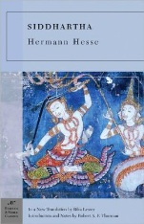

Siddhartha by Herman Hesse

Published in 1922, Siddhartha is the most famous and influential novel by Nobel prize-winning (1946) German author Hermann Hesse. Though set in India, the concerns of Siddhartha are universal, expressing Hesse's general interest in the conflict between mind, body, and spirit. The story follows a young man, a member of the highest caste in the Hindu religion, who leaves behind his wealth and privilege in a quest for spiritual self discovery.

The Sword in the Stone by T.H. White
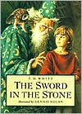
First published in 1938, The Sword in the Stone was originally a stand-alone novel chronicling the childhood of King Arthur as he discovers his true identify; however, it is often published as the first installment of the King Arthur saga embodied in The Once and Future King. Arthur, nicknamed Wart, embarks on an unlikely quest which leads him to his tutor, the magician, Merlin. Through a series of untraditional lessons, Merlin prepares the unsuspecting boy to be king.

Bless Me Ultima by Rudolpho Ananya
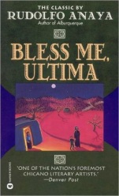
Published in 1972, Bless Me, Ultima has become one of the best-selling Chicano novels of all time. Set in Guadalupe, this is a coming of age story. Torn between his parents’ cultures, his Roman Catholic faith, and his spiritual connection to a traditional folk healer, Tony searches for his own identify. There is some coarse dialogue.

The Snow Child by Eowyn Ivey
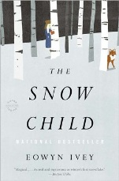
Alaska, 1920, was a brutal place to homestead, and especially tough for recent arrivals Jack and Mabel. Childless, they are drifting apart -- him breaking under the weight of the work of the farm; her crumbling from loneliness and despair. In a moment of levity during the season's first snowfall, they build a child out of snow. The next morning the snow child is gone--but they glimpse a young, blonde-haired girl running through the trees.
This little girl, who calls herself Faina, seems to be a child of the woods. She hunts with a red fox at her side, skims lightly across the snow, and somehow survives alone in the Alaskan wilderness. As Jack and Mabel struggle to understand this child who could have stepped from the pages of a fairy tale, they come to love her as their own daughter. But in this beautiful, violent place things are rarely as they appear, and what they eventually learn about Faina will transform all of them.

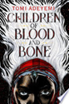Children of Blood and Bone by Tomi Adeyemi
Zélie Adebola remembers when the soil of Orïsha hummed with magic. Burners ignited flames, Tiders beckoned waves, and Zélie’s Reaper mother summoned forth souls.But everything changed the night magic disappeared. Under the orders of a ruthless king, maji were killed, leaving Zélie without a mother and her people without hope. Now Zélie has one chance to bring back magic and strike against the monarchy. With the help of a rogue princess, Zélie must outwit and outrun the crown prince, who is hell-bent on eradicating magic for good. Danger lurks in Orïsha, where snow leoponaires prowl and vengeful spirits wait in the waters. Yet the greatest danger may be Zélie herself as she struggles to control her powers—and her growing feelings for an enemy.

