Book Assignment

This year will begin with an assignment on the selection of books listed below.

These books are nonfiction accounts of people doing great things for others. The books, which are available in paperback, can be found at local libraries and bookshops. Choose at least one to read. As you read, use a highlighter and/or post-it notes to annotate the text, paying particular attention to passages you feel illustrate the power of the individual to effect change. All of the individuals are working against an oppressive system; if you are not familiar with the oppressive system, spend time learning more about it. Bring the book and all research with you to your first Advanced Placement English Language and Composition class. Read the following press releases for more information.

[](http://images.google.com/url?sa=i&rct=j&q=books&source=images&cd=&cad=rja&docid=5qaUEupTTrnXXM&tbnid=Bxdjfbf_1jYEoM:&ved=0CAUQjRw&url=http://melroserecycles.wordpress.com/2012/06/11/next-recycling-event-book-donation-day-june-16/&ei=hoeCUfSqF4L69QTHy4H4Aw&psig=AFQjCNF3ok-tL9LlBnvFtYCvv54yOAcgVw&ust=1367595163720702)

*Just Mercy*

by Bryan Stevenson

*JUST MERCY* is at once an unforgettable account of an idealistic, gifted young lawyer’s coming of age, a moving window into the lives of those he has defended, and an inspiring argument for compassion in the pursuit of justice. Through his own experiences and his work with juvenile offenders and the wrongly accused, we have a first-hand look at the broken criminal justice system.

[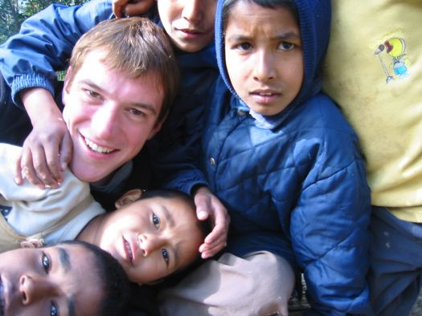](http://images.google.com/url?sa=i&rct=j&q=conor+grennan+little+princes&source=images&cd=&cad=rja&docid=FvXaXlJboh497M&tbnid=JimOQhev3MFiBM:&ved=0CAUQjRw&url=http://www.stamfordplus.com/stm/information/nws1/publish/News_1/Author-Conor-Grennan-at-Wilton-Library-March-811962.shtml&ei=9IGCUZ37KYLa9QSDt4C4BQ&psig=AFQjCNEG8UvuDV0T0LNKguEne7KOXQnIDw&ust=1367593785774154)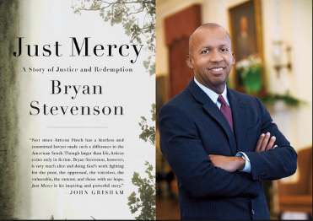

*Little Princes: One Man’s Promise to Bring Home the Lost Children of Nepal*

by Conor Grennan

Little Princes is the epic story of Conor Grennan's battle to save the lost children of Nepal and how he found himself in the process. Part Three Cups of Tea, part Into Thin Air, Grennan's remarkable memoir is at once gripping and inspirational, and it carries us deep into an exotic world that most readers know little about.

*Mountains Beyond Mountains*

by Tracy Kidder

Paul Farmer found his life’s calling: to cure infectious diseases and to bring the lifesaving tools of modern medicine to those who need them most. Kidder’s magnificent account takes us from Harvard to Haiti, Peru, Cuba, and Russia as Farmer changes minds and practices through his dedication to the philosophy that “the only real nation is humanity.”

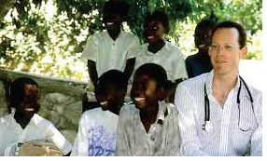

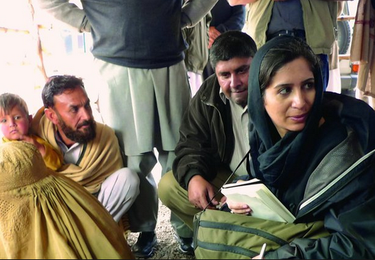

*I Was Told To Come Alone: My Time Behind the Lines of jihad*

By Souad Mekhennet

In this compelling and evocative memoir, we accompany Mekhennet as she journeys behind the lines of jihad, starting in the German neighborhoods where the 9/11 plotters were radicalized and the Iraqi neighborhoods where Sunnis and Shia turned against one another, and culminating on the Turkish/Syrian border region where ISIS is a daily presence. In her travels across the Middle East and North Africa, she documents her chilling run-ins with various intelligence services and shows why the Arab Spring never lived up to its promise. She then returns to Europe, first in London, where she uncovers the identity of the notorious ISIS executioner “Jihadi John,” and then in France, Belgium, and her native Germany, where terror has come to the heart of western civilization.[](http://images.google.com/url?sa=i&rct=j&q=newspapers+and+magazines&source=images&cd=&cad=rja&docid=omn5DYbFLubyRM&tbnid=k5byPkA66j3KrM:&ved=0CAUQjRw&url=http://www.mphpl.org/newSite/newspapers/&ei=qIWCUZ-fIIf68gTpxYHQAw&psig=AFQjCNFgau2SmphzlGyTT3esF2K_8mgdvA&ust=1367594630736592)stern Civilization.



Newspaper/Magazine Editorial Reading Assignment

The focus of Advanced Placement English Language and Composition is understanding, analyzing, and writing non-fiction prose. This assignment gives you practice in reading and responding to essays and arguments.

Over the summer, read and clip (or print) at least five editorials or commentaries/essays (not news articles or informational features) from reputable newspapers or issues-based magazines (most of which you can access on-line.) Mix-and-match, using different types of sources. You may choose to focus your reading on a specific topic (i. e., global warming) or you may read on a number of different topics.

Then, comment on the aspects of each of the editorials that made you think, and your thoughts about the editorial or the issues—one response per editorial. Your responses should be thoughtful, specific, and detailed. Your language should be accurate, precise, and specific. Remember what you have learned about effective writing and apply those skills. Avoid filler phrases (I think, I feel, in my opinion.)

You might consider the following questions but that does not mean you should write in first person. Apply the skills you have learned

* Do you agree or disagree with the writer’s viewpoint(s)? Why?
* Did the editorial make you want to know more about the issue? In what way?
* What are some of the writer’s best arguments? What makes them effective?
* Which arguments or points made by the writer do not make sense to you and why?
* How does this editorial connect with other knowledge that you have from other sources?
* Something else this editorial makes you think about . . .

Neatly put together the readings and your responses to hand in on the first day of class. **Make sure you provide the MLA documentation for each source—do this correctly! You will be evaluated on this activity, so don’t neglect this responsibility. Use a style guide—we recommend the Purdue Online Writing Lab (OWL).**

And finally . . . do some leisure reading! 