Advanced American Literature
Mrs. Core & Ms. Steinmann
Advanced American Literature Team

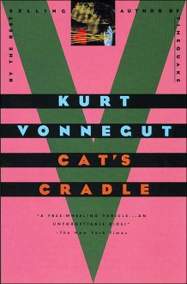
Students entering Advanced American Literature are asked to select one of the novels below and read it over the summer. Students will read and take notes over the novel. The notes are required and will be collected and assessed when students arrive in the fall. In addition to reading and taking notes, students will write an in-class essay over this book.

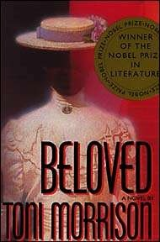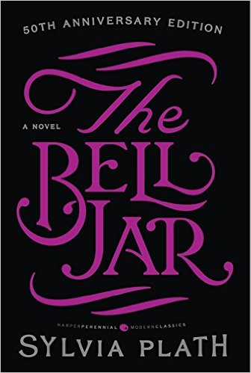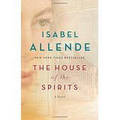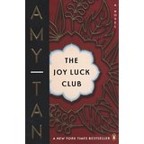

Toni Morrison  Beloved | Sylvia Plath  The Bell Jar | Isabel Allende  The House of the Spirits | Amy Tan  The Joy Luck Club | Kurt Vonnegut  Cat’s Cradle

On your own paper create a chart like the sample below and use the chart to take notes. Please use 8½” x11” paper without fringes. Use blue or black ink, or type this chart and print it out.

title and author:
plot summary:

main characters and brief description of each:

minor characters and brief description of each:

setting (time and place story occurs)

theme (One theme that gives the reader insight into human life is … ) add relevant symbols and motifs and explain:

literary elements (flashback, foreshadowing, irony…) and extra story notes:

conflict (describe ):

