***Intermediate Art History***

**Becky S. Johnson – Instructor**

**\*A Days 7:25-3:10 p.m. Room 3011 3rd Floor Central Campus**

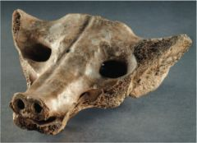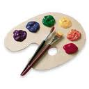C:\STOCKLAYOUTS\CURRENT PROJECTS\FN99803-PL\FN99803-IMG06.emfC:\STOCKLAYOUTS\CURRENT PROJECTS\FN99803-PL\FN99803-IMG11.emfC:\STOCKLAYOUTS\CURRENT PROJECTS\FN99803-PL\FN99803-IMG10.emf

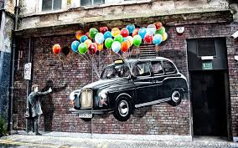

COURSE OBJECTIVES

provides a foundation for a historical understanding of visual conventions, including both western and non-western cultures.

* introduces the expressive potential of visual forms, applies rigorous methodologies for the study of perception and interpretation of the visual world.
* requires students to be makers as well as interpreters, i.e. through the fabrication of visual essays and statements using new or traditional media.
* prepares the student to view and understand information presented in modes used in a variety of disciplines and areas.
* upon successful completion of the course, students will have a working knowledge of the

vocabulary necessary for objective description of art

objects, media, techniques, and styles.

* Students will understand the context out of which art has been made in the past, present, and its potential impact on the future of visual culture.



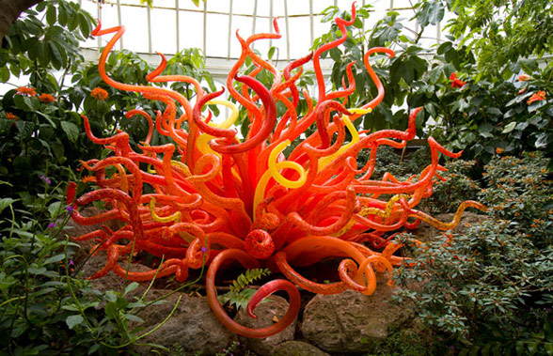

LOGISTICS

* Materials are furnished for the majority of assignment with additional materials at students own expense.
* Students are required to purchase their own sketchbook to be brought to class on a daily basis. The sketchbook will be evaluated as part of your planning grade and will incorporate: class notes, handouts, and preliminary class drawings, journaling, as well as personal design and drawing pursuits

Central Academy Des Moines Public Schools

**ART XXX/XXX, Intermediate Art History S1 and S2 :**  
In this course, students will develop a basic vocabulary for describing visual art, an in-depth understanding of the functions of imagery, and explore the role art has played throughout Western and Non-Western history and contemporary trends. The focus of this course is describing, exploring, and participating in the creative process in order to better understand the role of art in history. This course is recommended for students considering careers in architecture, art education, art history, ceramics, fashion design, interior architecture, interior design, landscape design, or studio art or future enrollment in the AP Art History course.  
 





Text: The Annotated Mona Lisa – Carol Strickland

Art History – Stokstad/Cothren

**Plagiarism is the misrepresentation of another’s ideas, phrases, discourse, or works as one’s own; it is not tolerated at Academy**

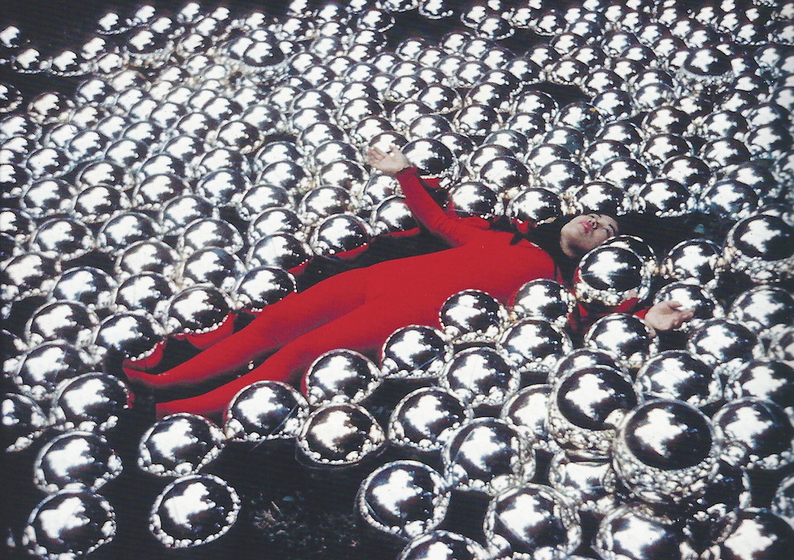

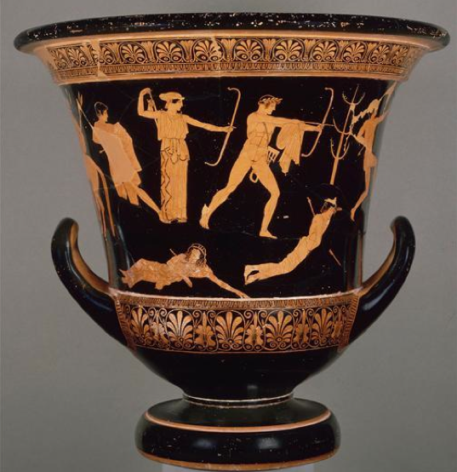

Contemporary communication in our modern world depends now, more than ever, on visual media and less on the written word & speech. Images can be extremely effective tools for conveying information and mood, and it is important for us to appreciate the power—for good and bad—of visual media. Students will demonstrate a basic understanding of the techniques, history, and interpretation of the conventions of visual culture.

Through lectures, readings, gallery visits and hands-on activities, students will develop an understanding of the functions of imagery in art, a basic vocabulary for describing visual art, a general understanding of the role art has played throughout Western and Non-Western history, and contemporary trends. Emphasis will also be given to the creative process.

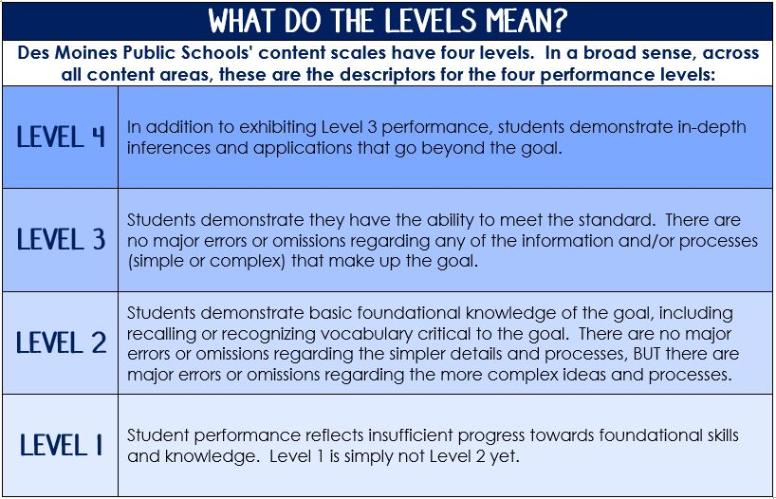

* Original goals & objectives met.
* Creative energy used, intent, commitment
* Craftsmanship demonstrated (pride in your work – remember its quality, not quantity that counts!)
* Time on task. Time management and completion dates met. * **All assignments are due by deadline set by instructor! * Late work will only be accepted within that 6 week grading period, but students may have other chances to demonstrate proficiency.**

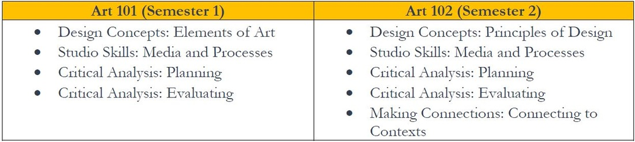

**Student attendance** on a daily basis is critical to student achievement and success in school. Central Academy has high expectations for students to be in attendance each day to be able to benefit from their teachers’ daily instruction.

* A sketchbook, minimum 100 pages – spiral bound
* Pencils and eraser
* **A Donation of one of following:**
* A box of Kleenex
* Hand lotion,
* Antibacterial soap
* Band Aids
* Roll of paper towels

T

**REQUIRED SUPPLIES**

Grades are dependent on …

**academic integrity:**

Experience vs.

Discipline