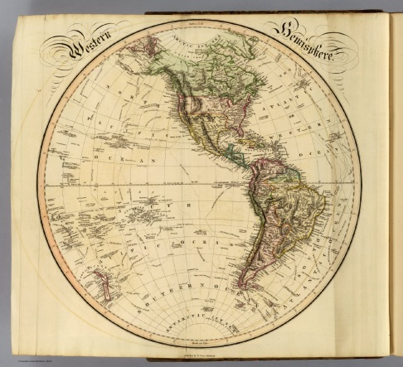
IB History of the Americas Summer Reading Assignment
Welcome to IB History of the Americas! I’m so glad you decided to take this course! Please read the following information carefully and closely.
IB Mission Statement: “The IB Organization aims to develop inquiring, knowledgeable, and caring young people who help to create a better and more peaceful world through intercultural understanding and respect. To this end IBO works with schools, governments and international organizations to develop challenging programmes of international education and rigorous assessment. These programmes encourage students across the world to become active, compassionate and lifelong learners who understand that other people, with their differences, can also be right.” November 2002
IB Course Description: “History is more than the study of the past. It is the process of recording, reconstructing and interpreting the past through the investigation of a variety of sources. It is a discipline that gives people an understanding of themselves and others in relation to the world, both past and present. History of the Americas covers major developments in the region from around 1760-2000: independence movements; the challenges of nation-building; the emergence of the Americas in global affairs; the Great Depression; the Second World War and the Cold War; and their impact on the region, as well as transition into the 21st century. Within each section political, economic, and social issues are considered and, when relevant, cultural aspects are included. The countries of the Americas form a region of great diversity but close historical links.”
*In this course the US history competencies will be taught to earn US history credit as determined by the State of Iowa.
The topics we will cover in this course are listed below, the 3 topics in bold will be covered in-depth to help you complete the IB HOTA test (otherwise known as Paper 3).
- Independence Movements
- Nation-building and challenges
- US Civil War: Causes, course and effects 1840-1877
- Development of modern nations 1865-1929
- Emergence of the Americas in global affairs 1880-1929
- Mexican Revolution 1910-1940
- Great Depression and the Americas 1929-1939
- The Second World War and the Americas 1933-1945
- Political developments in the Americas after the second World War 1945-1979
- Cold War and the Americas 1945-1981
- Civil Rights and social movements in the Americas
- Into the 21st century-from the 1980s to 2000

Assignments for the summer:
- Please bookmark our class website at www.historylearner.com.
Practice identifying all 20 Latin American nations, the 50 states, 10 provinces and 3 territories of Canada. A quiz will be given the 1st week of school and periodically through the year. The Latin American nations you need to ID include: Argentina, Bolivia, Brazil, Chile, Colombia, Costa Rica, Cuba, Dominican Republic, Ecuador, El Salvador, Guatemala, Haiti, Honduras, Mexico, Nicaragua, Panama, Paraguay, Peru, Uruguay & Venezuela.
- Read the syllabus for IB HOTA carefully. It is available on our class website under “IB HOTA.” Print off and place in page protector, if possible.
- Read the course information for IB HOTA carefully. It is available on our class website. Print off and place in page protector, if possible. Buy the required materials for the course.
- Read all documents on the Internal Assessments tab. Write down the due dates in your planner--a topic and research question will be due the first week of class!!!
- Read the note-taking guide. I will require Cornell note-form so read this thoroughly and understand how to take Cornell notes.
- Read the selected portions under “Latin America history” on our website, from John Chasteen’s book, Born in Blood and Fire. Read the excerpt for understanding first. Then, go back and write notes over important information in Cornell style. I provided an example in the “note taking guide.” This is due the first week of class. All notes will be kept in a 3-ring binder. Title your notes “Unit 1: Colonization, BB&F intro and chapter 1 notes.” This is also a great chance to work on your careful reading and note-taking skills as these skills are integral to any history course AND especially helpful to this one. You can type or write them.
- Find the “OPVL” under IB HOTA. Read the document to understand how to complete OPVL for primary and secondary sources. View the examples. Complete OPVL’s for all the primary sources attached. This is due the first week of class!
- Study the top 40 events in Western hemisphere history!
- Lastly, feel free to familiarize yourself with the National History Day competition at www.nhd.org. It is an optional assignment.

