Book recommendation list for summer reading (junior to senior year IB)
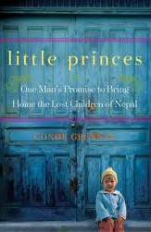
Connor Grennan Little Princes
This 304 page book is a non-fiction piece about a man who travels to Nepal to volunteer with orphans so he will look better to future employers. On his first day he is tackled by the little boys in the orphanage, and from then on he can’t get them out of his heart.

Dave Eggers What is the What
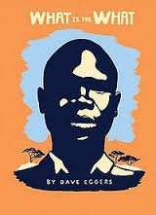
This 560 page fictionalized memoir details the “life of Valentino Achak Deng who, along with thousands of other children —the so-called Lost Boys—was forced to leave his village in Sudan at the age of seven and trek hundreds of miles by foot, pursued by militias, government bombers, and wild animals, crossing the deserts of three countries to find freedom. When he finally is resettled in the United States, he finds a life full of promise, but also heartache and myriad new challenges” (http://www.amazon.com/What-Dave-Eggers/dp/0307385906/ref=pd_sim_b_3).

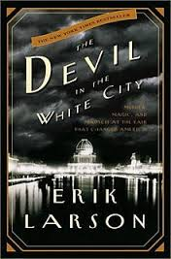
Erik Larson Devil in the White City
This 447 page non-fiction book takes place during the 1893 Chicago World’s Fair. It combines an architect’s story of building the “White City” and a serial killer’s story who used the fair to lure his victims. (this is the only one on this list I have no read).

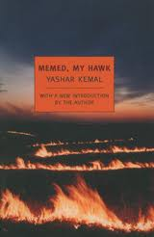
Yashar Kemal Memed, My Hawk
This 371 page book by Turkish author, Kemal, is about a boy growing up in poverty in a small village ruled by a cruel landlord. He fights back and ends up as a “brigand” trying to liberate his people and reunite with his first and only love. This will most likely only be found online but is in stock on Amazon. Please order early and give yourself two-three weeks to read this work

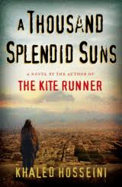
Khaled Hosseini A Thousand Splendid Suns
This 432 page book is about the women of Afghanistan and the sacrifices and trials they have had to endure. It is just as good as Kite Runner and was just used on the 2011 and 2013 AP exam. This delves into a lot of wonderful issues about women, love, loss, war, death, and friendship. You could find this at any local book store or library or you could order online.

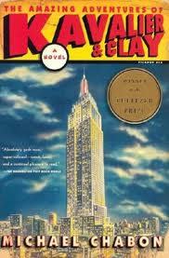
Michael Chabon Kavalier and Clay
This 656 page book is long but well worth it. It is about two boys who combine their talents (one for writing the stories and the other for his drawings) to create a comic book superhero. This book is about their relationship as they try to become successful publishing their comic books. It goes from comics about Hitler to the war to life after and beyond. It has escape artists and really shows how art can defy the chaos and idiocy of war.

