World Literature and Speech Honors English 9
Summer Reading - Central Academy
Ms. Miller, Mrs. Kellen, and Ms. Steinmann
Summer Reading Assignment: Over the summer, please read at least one of the books from the list below. Honors English 9 will survey world literature and examine how written language emerges in cultures often through the oral tradition of myth, poetry, and song. Each of the summer reading options contains some mythical qualities.

Read the novel once, just for enjoyment, and then skim it again, taking organized/structured notes in blue or black ink. These notes will be due the first week of class. Your notes should identify key characters from the novel and their relationships to the protagonist. Take notes over key plot points. Identify the major symbolic and/or mythical elements in the novel. Finally, identify 7-10 key passages which illuminate the novel’s big ideas. You may highlight those passages in your text or indicate them with sticky-notes.

Because there may be several weeks or even months between you reading the novel and writing the essay, your notes should be detailed and include page references. You will write an in-class essay over your summer reading choice.

Siddhartha by Herman Hesse
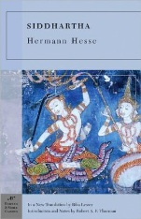
Published in 1922, Siddhartha is the most famous and influential novel by Nobel prize-winning (1946) German author Hermann Hesse. Though set in India, the concerns of Siddhartha are universal, expressing Hesse's general interest in the conflict between mind, body, and spirit. The story follows a young man, a member of the highest caste in the Hindu religion, who leaves behind his wealth and privilege in a quest for spiritual self discovery.

The Sword in the Stone by T.H. White
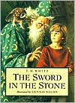
First published in 1938, The Sword in the Stone was originally a stand-alone novel chronicling the childhood of King Arthur as he discovers his true identify; however, it is often published as the first installment of the King Arthur saga embodied in The Once and Future King. Arthur, nicknamed Wart, embarks on an unlikely quest which leads him to his tutor, the magician, Merlin. Through a series of untraditional lessons, Merlin prepares the unsuspecting boy to be king.

Bless Me Ultima by Rudolpho Ananya
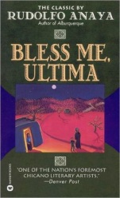
Published in 1972, Bless Me, Ultima has become one of the best-selling Chicano novels of all time. Set in Guadalupe, this is a coming of age story. Torn between his parents’ cultures, his Roman Catholic faith, and his spiritual connection to a traditional folk healer, Tony searches for his own identify. There is some coarse dialogue.

The Snow Child by Eowyn Ivey
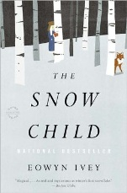
Alaska, 1920, was a brutal place to homestead, and especially tough for recent arrivals Jack and Mabel. Childless, they are drifting apart -- him breaking under the weight of the work of the farm; her crumbling from loneliness and despair. In a moment of levity during the season's first snowfall, they build a child out of snow. The next morning the snow child is gone--but they glimpse a young, blonde-haired girl running through the trees.
This little girl, who calls herself Faina, seems to be a child of the woods. She hunts with a red fox at her side, skims lightly across the snow, and somehow survives alone in the Alaskan wilderness. As Jack and Mabel struggle to understand this child who could have stepped from the pages of a fairy tale, they come to love her as their own daughter. But in this beautiful, violent place things are rarely as they appear, and what they eventually learn about Faina will transform all of them.

