We’re so excited that you are joining us at Central Academy this year! As a student entering eighth grade Honors English, you should take some time this summer to read to prepare for your English class. Please read one of the following books:
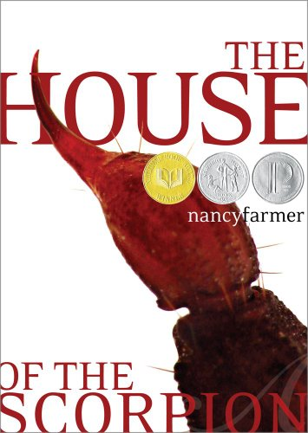
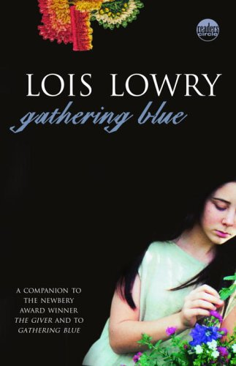
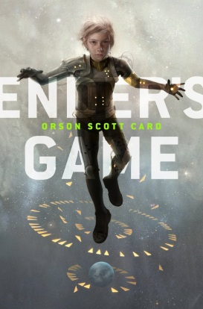

Orson Scott Card  Ender's Game  The Earth is under attack by aliens and the government is developing a group of military geniuses and training them with military games. Ender Wiggins is one of the trainees. | Nancy Farmer’s  The House of the Scorpion  A scientist brings Matteo to life from a frozen 100 year old cell. Matteo is a clone of a powerful drug lord. The novel traces his struggles to stay alive and his increasing awareness of the country named Opium. | Lois Lowry’s  Gathering Blue  Kira, a crippled young weaver and orphan, struggles to survive  in a post-disaster primitive society.
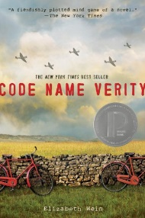 | Elizabeth E. Wein’s  Code Name Verity  Two young women, one a pilot and the other a spy, crash in World War II Nazi-held France. One is captured, held, and tortured while she writes a confession of her activities as a member of the resistance.

Read the book once for enjoyment. Pay attention to key passages or moments in the text that engage you. Think about the role that each character plays in the story. What is the author’s message? Then skim the text again, and fill out the major data works sheet.

Please bring your book and your major data works sheet with you to the first day of class.

Happy Reading!

