Advanced American Literature
Mrs. Core & Ms. Steinmann
Advanced American Literature Team

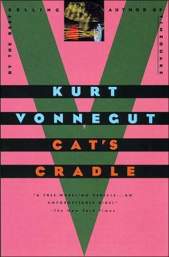
Students entering Advanced American Literature are asked to select one of the novels below and read it over the summer. Students will read and take notes over the novel. The notes are required and will be collected and assessed when students arrive in the fall. In addition to reading and taking notes, students will write an in-class essay over this book.

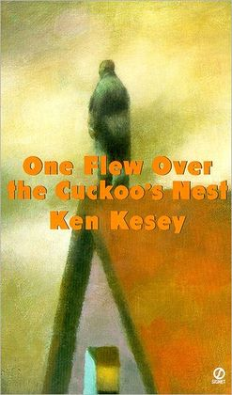
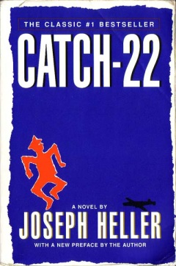
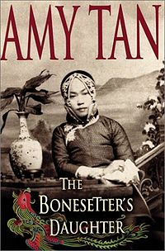
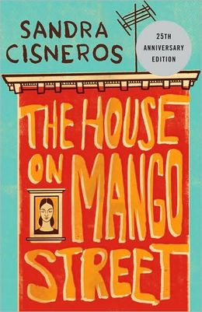

Sandra Cisneros’  House on Mango Street | Joseph Heller’s  Catch-22 | Ken Kesey’s  One Flew Over the Cuckoo’s Nest | Amy Tan’s  The Bonesetter’s Daughter | Kurt Vonnegut’s  Cat’s Cradle

On your own paper create a chart like the sample below and use the chart to take notes. Please use 8½” x11” paper without fringes. Use blue or black ink, or type this chart and print it out.

title and author:
plot summary:

main characters and brief description:

minor characters and brief description:

setting (time and place story occurs)

theme (One theme that gives the reader insight into human life is … ) add a motif and explain:

literary elements (flashback, foreshadowing, irony…) and extra story notes:

conflict (describe ):

